**Practical no. 5**

**FS19CO042**

**Aim:** Create network cable by crimping the straight and cross CAT5 cables and test it using Cable Tester.

1. Cable crimping
2. Standard cabling
3. Cross cabling
4. IO connector crimping
5. Testing the crimped cable using a cable tester

**Required components:** RJ-45 connector, IO connector, Crimping tool, Twisted pair cable, Cable tester

**Theory and steps:**

1. Standard/Straight Cabling

10BaseT and 100BaseT are most common mode of LAN. You can use UTP category-5 cable for both modes.

A straight cable is used to connect a computer to a hub.

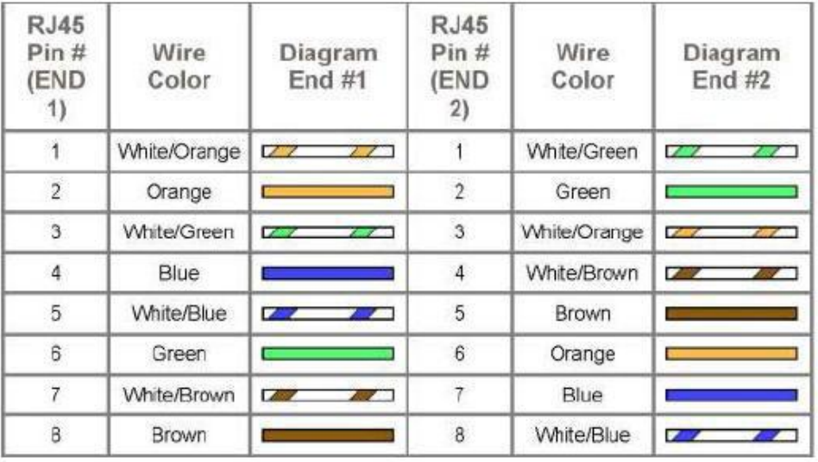

Cable arrangement:  
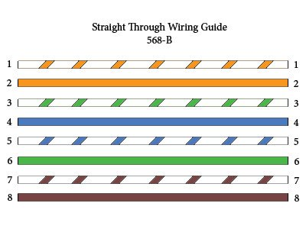

1. Cross Cabling

A cross cable is used to connect 2 computers directly (with ONLY the UTP cable). It is also used then you connect 2 hubs with a normal port on both hubs

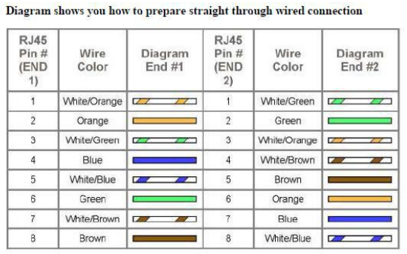

Cable arrangement:  
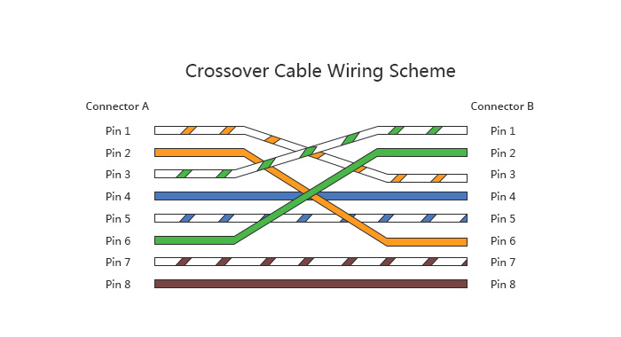

**Procedure:**

**Cable Crimping steps:**

**1.** Remove the outmost vinyl shield for 12mm at one end of the cable (we call this side A-side).

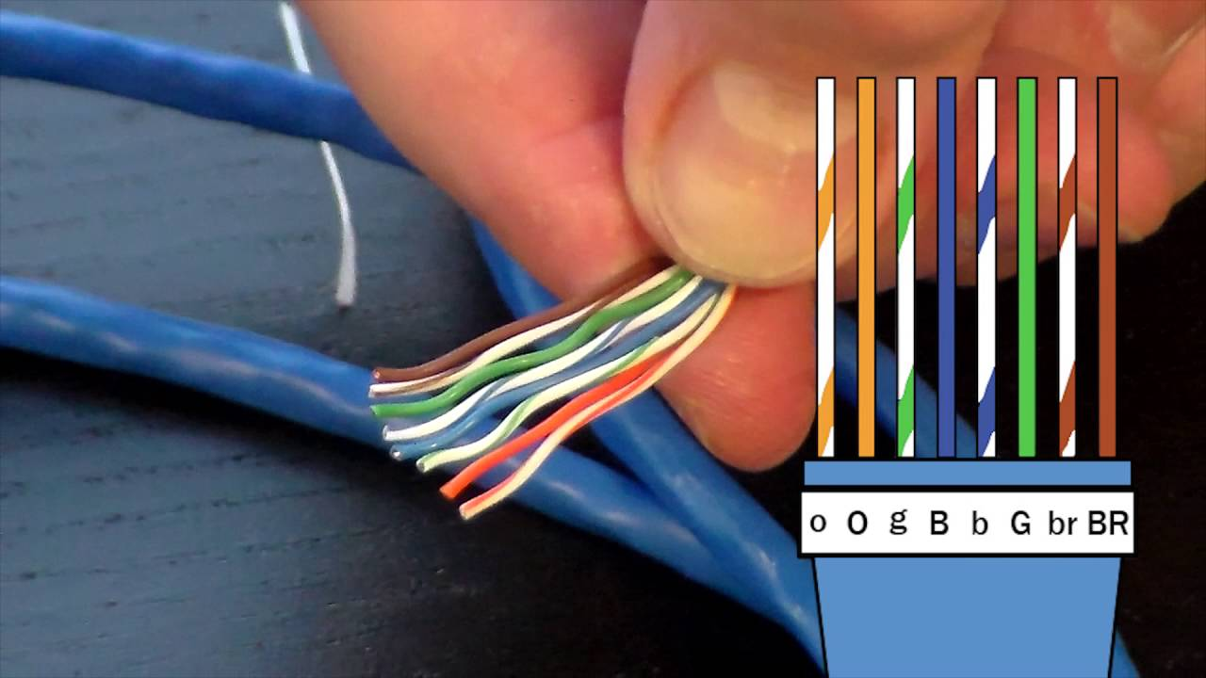2. Arrange the metal wires in parallel and cut ends evenly according to below diagram:

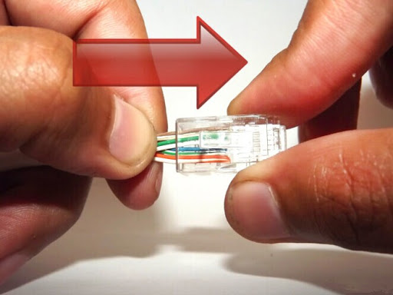3. Insert the metal wires into RJ45 connector on keeping the metal wire arrangement.

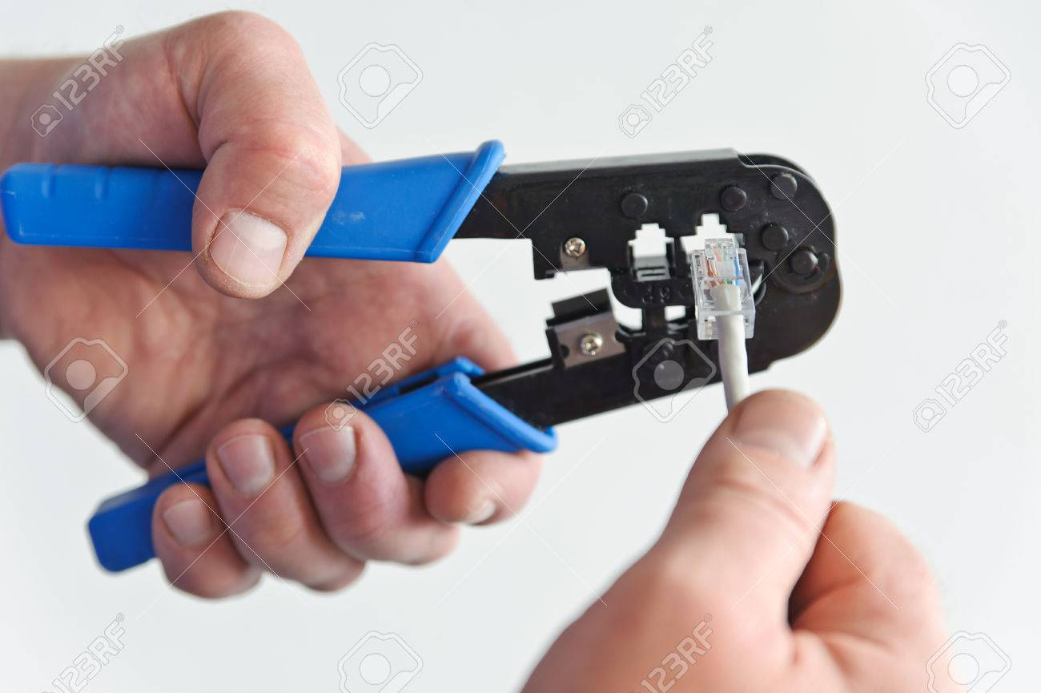4. Set the RJ45 connector (with the cable) on the pliers, and squeeze it tightly.

One end is ready

5. Make the other side of the cable (we call this side B-side) in the same way but with wire formation in   
 consideration.

6. Follow the cable organization depending upon type of cable to be made:

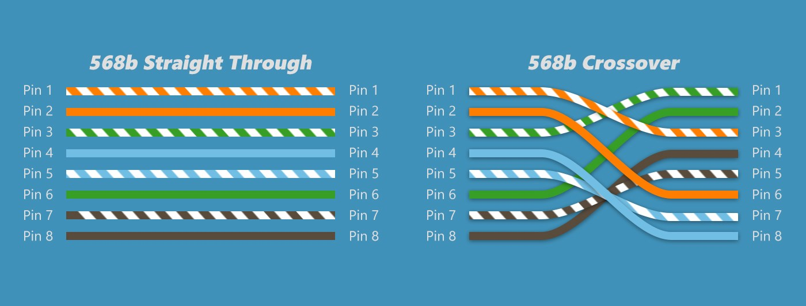

7. Set the RJ45 connector (with the cable) on the pliers, and squeeze it tightly similar to previous end of wire.  
The cable is prepared properly

**IO connector crimping**

Run the full length of Ethernet cable in place, from endpoint to endpoint, making sure to leave excess.

At one end, cut the wire to length leaving enough length to work, but not too much excess.

Strip off about 2 inches of the Ethernet cable sheath.

Align each of the colored wires according to the layout of the jack.

Use the punch down tool to insert each wire into the jack.

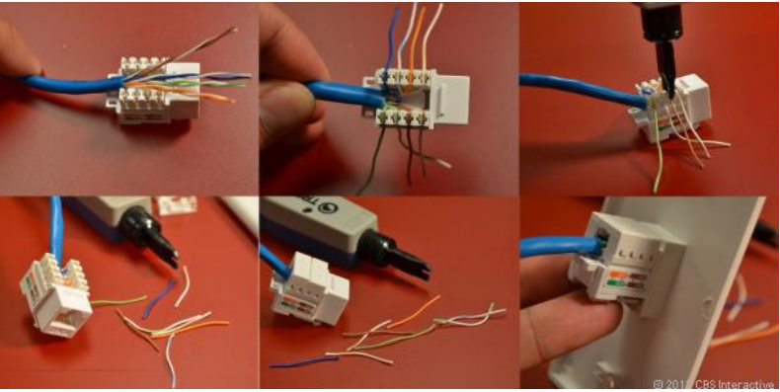Repeat the above steps for the second RJ45 jack.

**Testing the crimped cable using a cable tester.**

1. Take a Ethernet cable tester set.
2. Plug one end of the cable into the transmit jack (Tester with 2 ports).   
   The transmit jack on the tester maybe be labeled "TX".  
     
   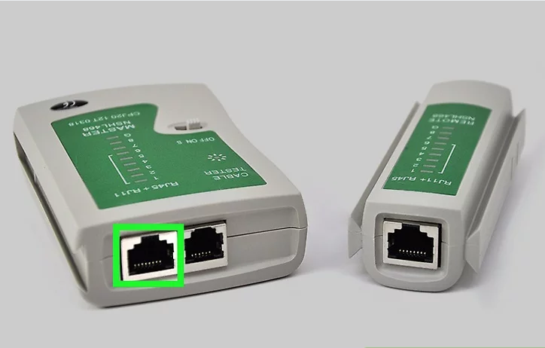
3. Plug the other end of the cable into the receiver jack.The receiver jack may be labeled "RX" on the device. Some testers have a detachable receiver you can use to test the cable across different rooms  
     
   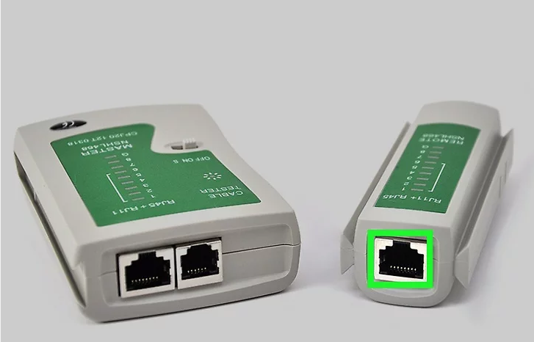
4. Check the lights on the tester. Most testers will have 2 sets of 8 LED lights that correspond to the 8 pins on the transmitting and receiving end of the Ethernet cable. There will also be a G light for the ground.   
   It will test each pin one at a time. If all 8 pins light up on both ends, the cable is good. If any of the lights do not light up on either end, this indicates a short in the cable.   
   Don't worry if the G light doesn't light up. I  
   f the lights on either end flash out of order, this indicates that you are testing a crossover cable. As long as all 8 lights flash, the cable is good  
     
   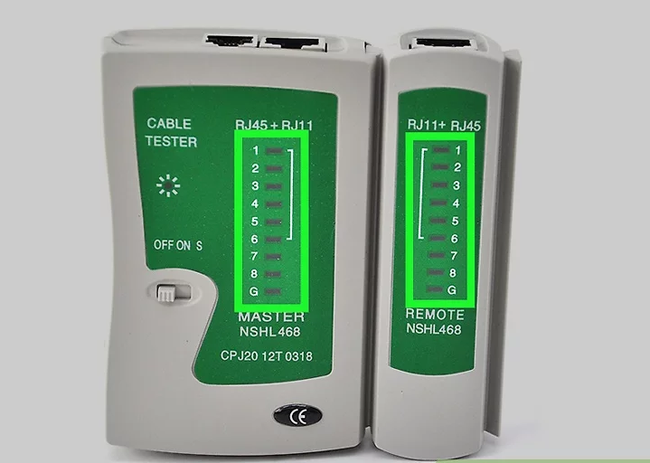

**Conclusion: Thus we learnt to build network cable by crimping the straight and cross CAT5 cables as well as IO**

**connector and test cable using Cable Tester.**